| PART NAME |
| --- |
| TEA-4040TC Cladding Manipulator |

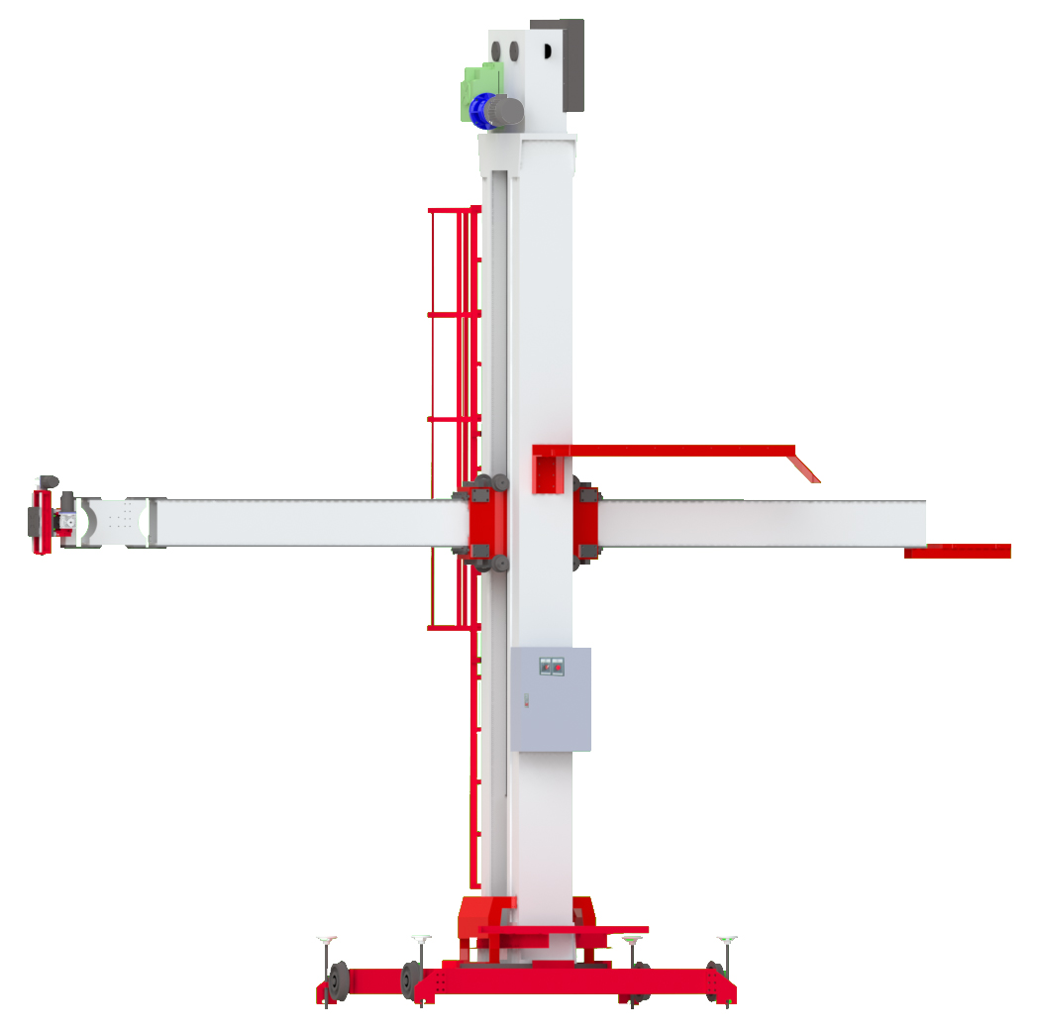

**Chapter 4: Control panel**

4.1 Remote Controller __page11

4.2 Move up & Move down __page12

4.3 Advance (Move right) __page13

4.4 Backward (Move left) __page14

4.5 Remote Controller Box-Joystick __page15

4.6 Remote Controller Box-Speed Adjustment __page15

4.7 TEA-XY2 Electric Slide__page16

**Chapter 5: Appendix**

Wiring diagram __I~II

Mechanical assembly __III~VII

**Chapter 1: Function**

1.1 Product mix __page1

1.2 Function __page2

1.3 Size __page3

**Chapter 2: Safe and explaining**

2.1 Emergency Stop __page4

2.2 Power __page5

**Chapter 3: Installation**

3.1Input power __page6

3.2 Cooling water & Remote control box __page7

3.3 Welder __page8

3.4 Welder Location __page9

3.5 TEA-XY2 __page10

Contents

**Chapter 1: Function**

| 1.1 |
| --- |
| Product mix |



Travel car

TEA-XY2 Electronic slide

Safety stairs

Control box

1

| 1.2 |
| --- |
| Function |

|  |  |
| --- | --- |
| Specification / model | TEA-4040BP |
| Boom Horizontal Stroke | 4,000mm. |
| Boom Horizontal Speed | 150 – 1,500 mm/min. |
| Arm Rotation Angle | 180º |
| Boom Vertical Stroke | 4,000mm. |
| Boom Vertical Speed | 800 mm/min. |
| Boom End Max. Load | 120 Kgs. |
| Column Rotation Angle | 360º |
| Column Rotation Drive | Pushing of Boom |
| Installation | On the ground |
| Movement | Pushing of Column |
| Track Type | 15 kg Rail |
| Control | Hand Remote Box / The wire is 10M Cable( Inch Up, Inch Down, Left / Right, Inch / Hold, Boom Speed, Welder ON/OFF ) |
| Power | AC380V/7A/3Ø/4.6kw |

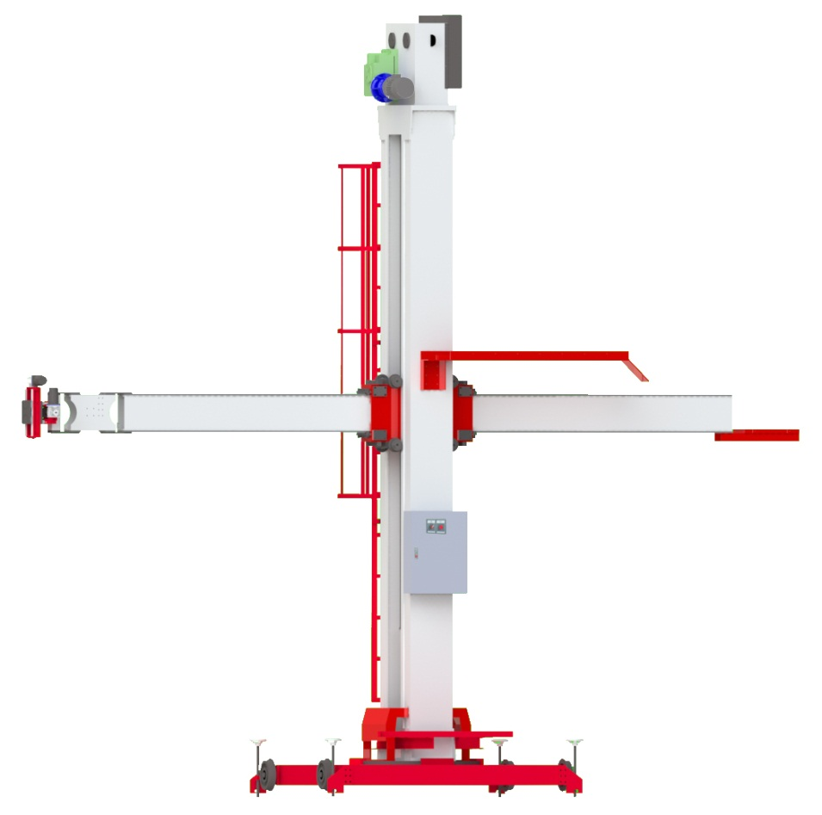

2



| 1.3 |
| --- |
| Size |

UNIT: mm

3

**Chapter 2 : Safe and explaining**

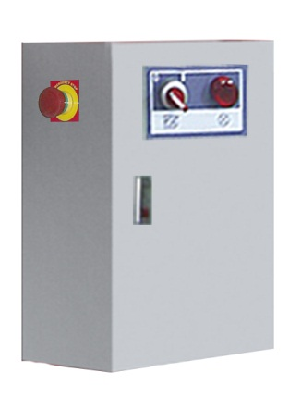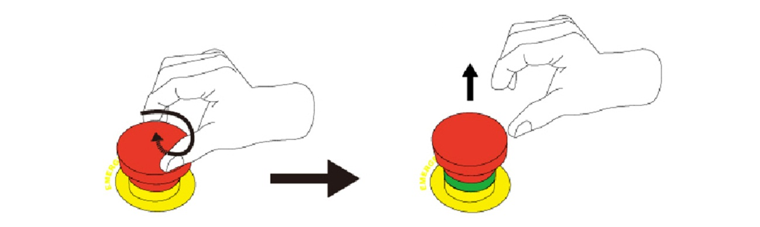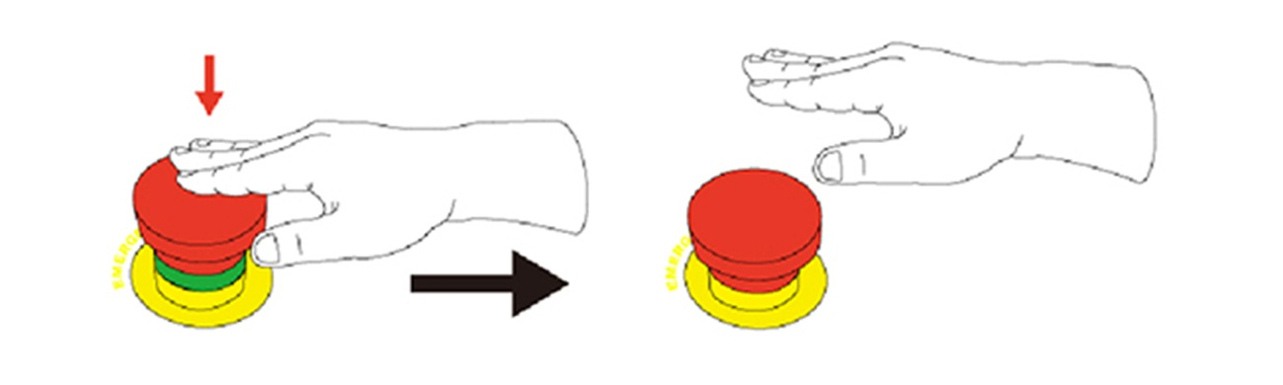

4

Emergency Stop

| 2.1 |
| --- |
| Emergency Stop |

●The power and all control movements are closed at the same time.

●The power and all control movements resume the function.

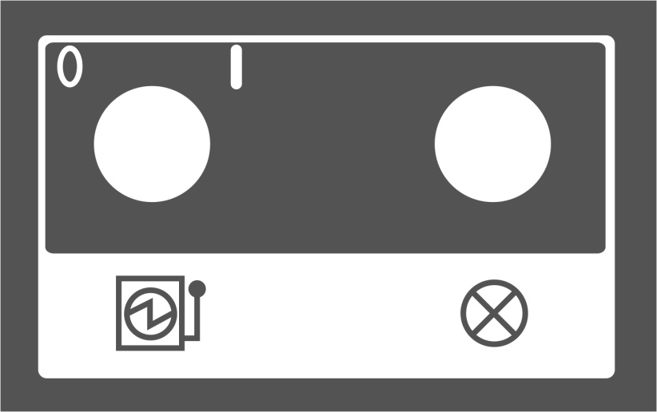

5

| 2.2 |
| --- |
| Power |

Power ON

Power OFF

**Chapter 3: Installation**

| 3.1 |
| --- |
| Input power |



AC 380V/10A/3Ø

6

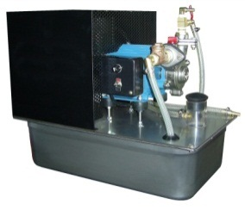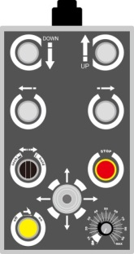

| 3.2 |
| --- |
| Cooling water & Remote control box |

7

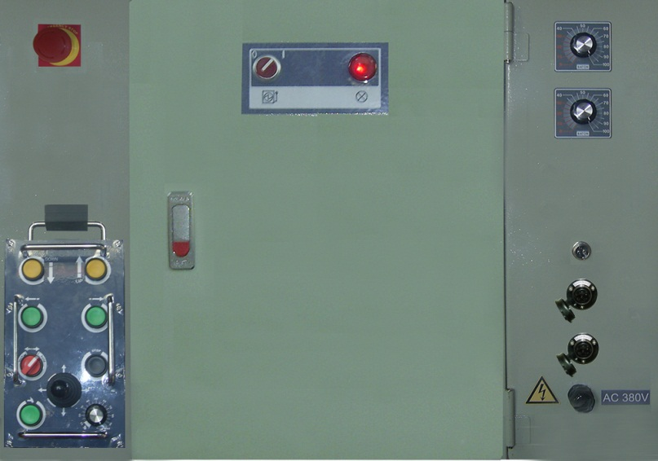

Control Box

The welder starts wire

TIG or Plasma weld power source

8

| 3.3 |
| --- |
| **Welder** |

| 3.4 |
| --- |
| **Welder Location** |



Welder

9

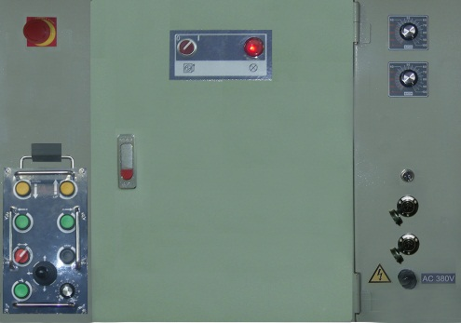

10

X

Y

Y

X

| 3.5 |
| --- |
| **TEA-XY2** |

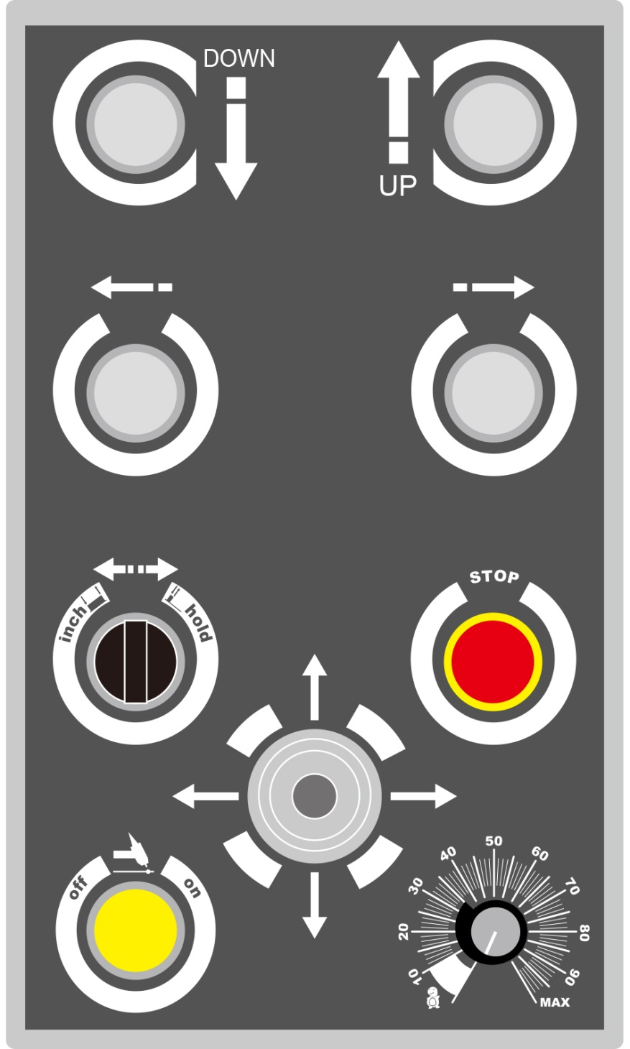

**Chapter 4: Control panel**

Advance (Move right)

Joystick(X, Y - Axis)

Welder start / stop

Boom speed

Stop (Hold valid)

Inch / Hold

Backward (Move left)

Move up

Move down

11

| 4.1 |
| --- |
| Remote Controller Panel |

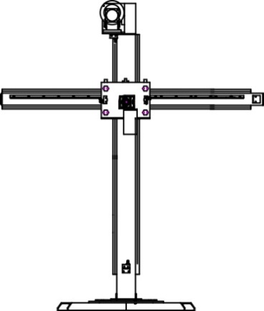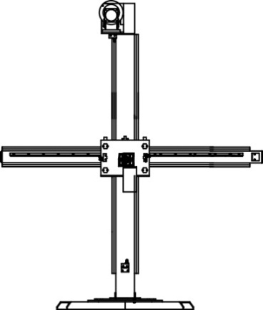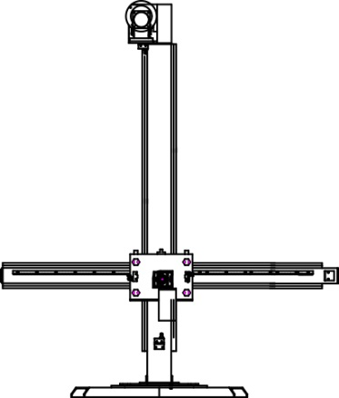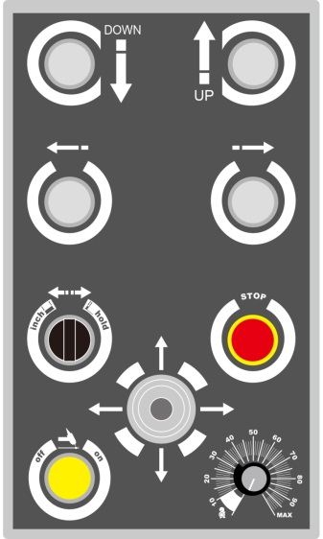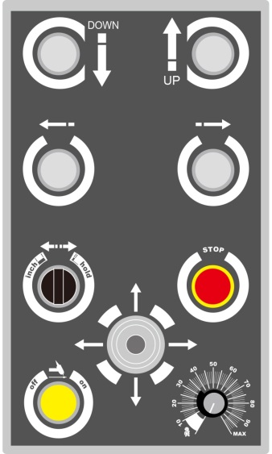

12

| 4.2 |
| --- |
| Move up & Move down |

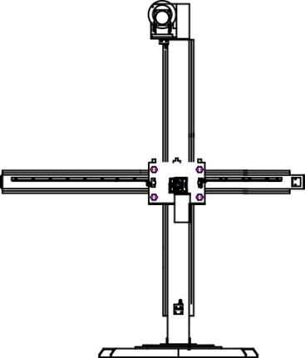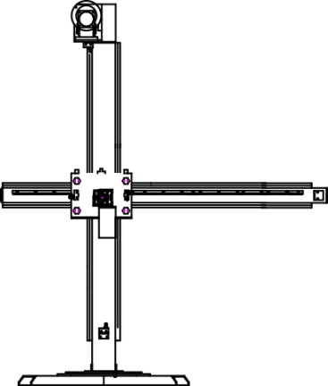

| 4.3 |
| --- |
| Advance (Move right) |

Inch Mode

Hold Mode

Stop

Stop

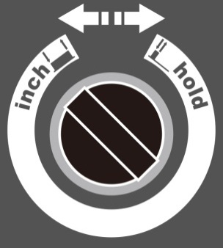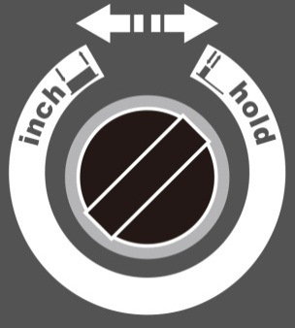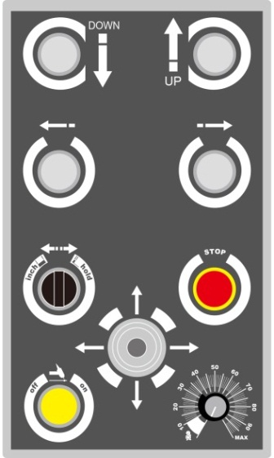

Boom speed

13

14

| 4.4 |
| --- |
| Backward (Move left) |

Stop

Stop

Inch Mode

Hold Mode

Boom speed

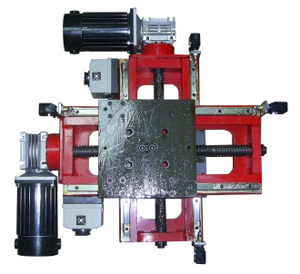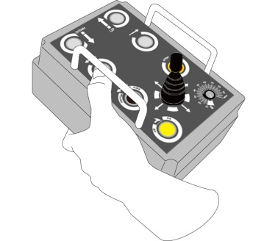

| 4.5 |
| --- |
| Remote Controller Box - Joystick |

TEA-XY2

15

| 4.6 |
| --- |
| Remote Controller Box - Speed Adjustment |

Control Box

TEA-XY2

Control Box

TEA-XY2

TEA-XY2

|  |  |
| --- | --- |
| Specification / model | TEA-XY2 |
| Load | 50Kgs. |
| Load Level stroke (X axle) | 180mm. |
| Level speed | 300mm/min |
| Vertical stroke (Y axle) | 180mm. |
| Vertical speed | 300mm/min |
| Control operation | Rocker |



16

| 4.7 |
| --- |
| TEA-XY2 Electric Slide |

UNIT: mm

**Chapter 5 : Appendix**

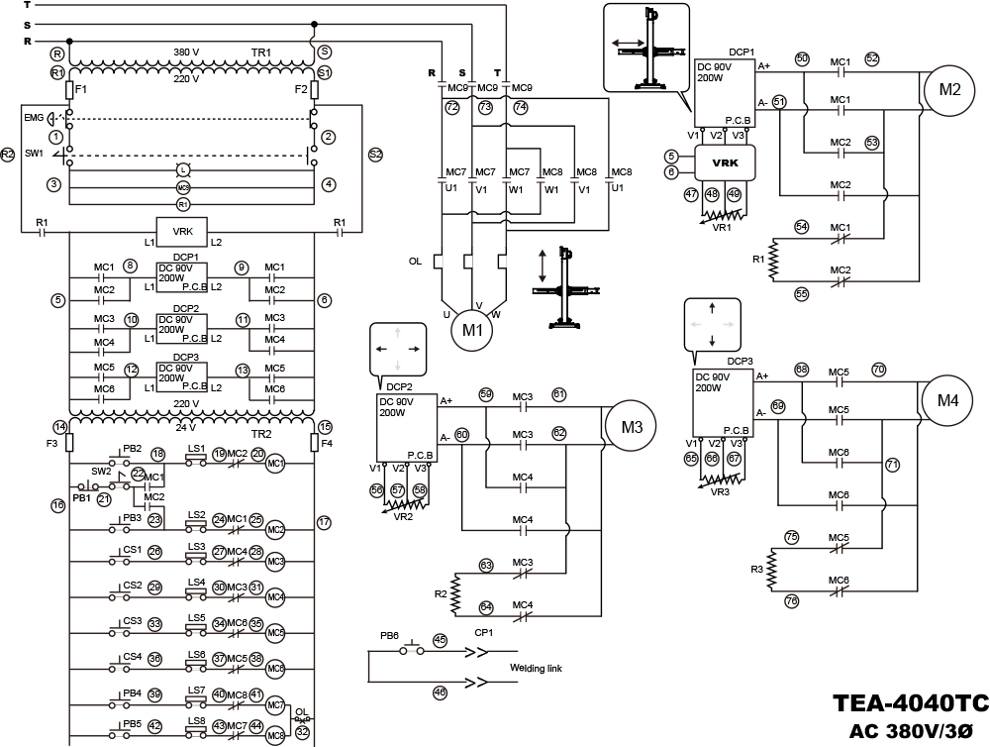

I

|  |
| --- |
| Wiring diagram |

|  |
| --- |
| Wiring diagram |



II

|  |
| --- |
| **Mechanical assembly** |

|  |  |  |  |
| --- | --- | --- | --- |
| Item | Type | Description | Q'TY |
| LS1 | TZ-7312 | Limit Switches | 1 |
| LS2 | TZ-7312 | Limit Switches | 1 |
| LS7 | TZ-8104 | Limit Switches | 1 |
| LS8 | TZ-8104 | Limit Switches | 1 |
| M1 | 3Ø AC380V/2HP Motor | AC Motor | 1 |
| M2 | DC180V/200W Motor | DC Motor | 1 |



III

|  |  |  |  |
| --- | --- | --- | --- |
| Item | Type | Description | Q'TY |
| LS3 | V-153-1A5 | Limit Switches | 1 |
| LS4 | V-153-1A5 | Limit Switches | 1 |
| LS5 | V-153-1A5 | Limit Switches | 1 |
| LS6 | V-153-1A5 | Limit Switches | 1 |
| CP4 | PLT-256-R | Socket | 1 |
| CP5 | PLT-256-R | Socket | 1 |
| M3 | DC90V/65W Motor | DC Motor | 1 |
| M4 | DC90V/65W Motor | DC Motor | 1 |



IV

|  |
| --- |
| **Mechanical assembly** |



|  |
| --- |
| **Mechanical assembly** |

|  |  |  |  |
| --- | --- | --- | --- |
| Item | Type | Description | Q'TY |
| VR2 | RV24YN 20S/B502/5KΩ | Variable Resistor | 1 |
| VR3 | RV24YN 20S/B502/5KΩ | Variable Resistor | 1 |
| EMG | A20B-V4E02R/2b | Emergency Stop Switches | 1 |
| SW1 | A20S-2E20R/2a | Selector Switches | 1 |
| L | A20P-1BEQM3R | Pilot Lights | 1 |
| CP1 | PLT-163-R-R | Socket | 1 |
| CP2 | PLT-256-RF | Socket | 1 |
| CP3 | PLT-256-RF | Socket | 1 |

V

|  |  |  |  |
| --- | --- | --- | --- |
| Item | Type | Description | Q'TY |
| DCP1 | DCP-200V9A12 | DC Motor Driver P.C.B. | 1 |
| DCP2 | DCP-200V9A12 | DC Motor Driver P.C.B. | 1 |
| DCP3 | DCP-200V9A12 | DC Motor Driver P.C.B. | 1 |
| VRK1 | VRKS-DC180V2 | VR Link P.C.B. | 1 |
| R | 2Ω50W | Braking Resistor | 3 |
| TR1 | 110V/440V/5A | Transformer | 1 |
| TR2 | PT-26-18W | Transformer | 1 |
| F1 | FUSE 30mm/5A | Fuse | 1 |
| F2 | FUSE 30mm/5A | Fuse | 1 |
| F3 | FUSE 30mm/3A | Fuse | 1 |
| F4 | FUSE 30mm/3A | Fuse | 1 |
| R1 | MY-2N/220V2P/10A | Relay | 1 |
| MC1 | CU-11/24V/4A+CUA-422 | Magnetic Contactor+Auxiliary Contact | 1 |
| MC2 | CU-11/24V/4A+CUA-422 | Magnetic Contactor+Auxiliary Contact | 1 |
| MC3 | CU-11/24V/4A+CUA-202 | Magnetic Contactor+Auxiliary Contact | 1 |
| MC4 | CU-11/24V/4A+CUA-202 | Magnetic Contactor+Auxiliary Contact | 1 |
| MC5 | CU-11/24V/4A+CUA-202 | Magnetic Contactor+Auxiliary Contact | 1 |
| MC6 | CU-11/24V/4A+CUA-202 | Magnetic Contactor+Auxiliary Contact | 1 |
| MC7 | CU-11/24V/3A1b | Magnetic Contactor | 1 |
| MC8 | CU-11/24V/3A1b | Magnetic Contactor | 1 |
| MC9 | CU-11/220V/3A1b | Magnetic Contactor | 1 |
| OL | RHU-10/4.8K1 | Thermal Overload Relay | 1 |

|  |
| --- |
| **Mechanical assembly** |



VI

|  |  |  |  |  |
| --- | --- | --- | --- | --- |
| Item | Type | Description | Function | Q'TY |
| VR1 | RV24YN 20S/B502/5KΩ | Variable Resistor | Speed | 1 |
| VR1-1 | RN-99D | Knobs |  | 1 |
| SW2 | A20S-2E11R/1a1b | Selector Switches | Inch/Hold | 1 |
| PB1 | A20B-M1E11B/1a1b | Push Buttons | Stop | 1 |
| PB2 | A20B-M1E11G/1a1b | Push Buttons | Forward | 1 |
| PB3 | A20B-M1E11G/1a1b | Push Buttons | Backward | 1 |
| PB4 | A20B-M1E11Y/1a1b | Push Buttons | Down | 1 |
| PB5 | A20B-M1E11Y/1a1b | Push Buttons | Up | 1 |
| PB6 | A20B-M1E11G/1a1b | Push Buttons | Welding Link | 1 |
| CS1 | TMR-304-2222-10101010 | Cross Switch | X-Axis Right | 1 |
| CS2 | TMR-304-2222-10101010 | Cross Switch | X-Axis Left | 1 |
| CS3 | TMR-304-2222-10101010 | Cross Switch | Y-Axis Up | 1 |
| CS4 | TMR-304-2222-10101010 | Cross Switch | Y-Axis Down | 1 |



VII

|  |
| --- |
| **Mechanical assembly** |